MASTERWEB STORES DOCUMENTATION
Masterweb Stores (MS) is a simple and powerful ecommerce system. It works with all modern browsers, but we recommend Google Chrome. MS is constantly updated, so it is possible for a documentation to become outdated. Latest documentations are available for download at stores.masterweb.com.ng which also has an installation of the latest version of MS. All you need do is scroll to the About section.
MS has the following major features:
- Inventory management
- User funds management
- Accounting features (export CSV for reporting)
- Shipping/Delivery management
- Several payment options
- Coupon Code and Discount Promotions
- Front page Gallery system integrated
- Shopping Cart, Invoicing system and Order Management
- Live Chat system integrated
- Support Ticketing
- Affiliate Programs
- Free Google Analytics Tracking Integration
- Responsive and compatible with Mobile devices
- Content Management System for pages
- Customer Review/Rating
- Dark Mode/Night Browsing
- RSS FEED push notification and Wishlist to increase retention
- Email List Generation
- Receipt and QR Code
- Payment Gateways
There are more features that we shall get to discover, and learn how to use as we go further in this documentation.
The first part of this document deals with getting started with MS. How to use more advanced features are treated in the end.
Screenshots are included so that you are able to see what is being referred to, without leaving this documentation. But the easiest way to learn is to practice with an MS installation.

GETTING STARTED
After a new installation, a super-user email, password and PIN are usually handed over to the merchant. Please login with the information and you will discover a new tab just below the header of the website that says – Hi Admin! Click Here To Check Admin Dashboard.
This simply shows that you are an admin. When you click on that, you are brought to the admin dashboard. It looks somewhat like the screenshot below.
So whenever you are asked to go to the admin dashboard or simply dashboard, this is where you go to.
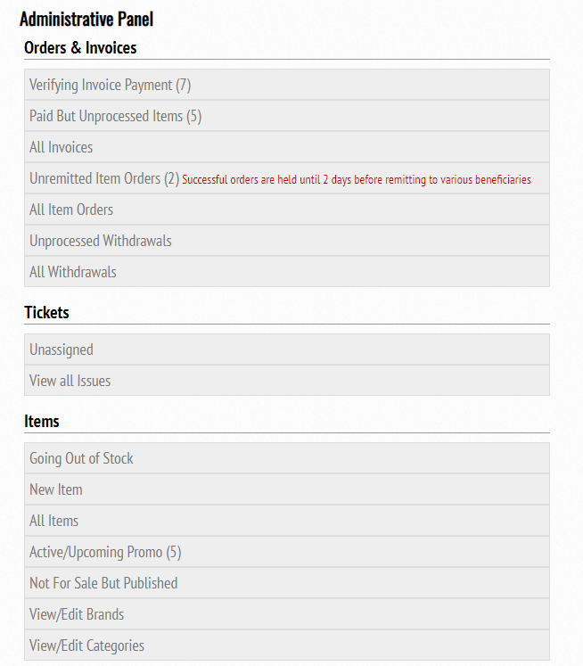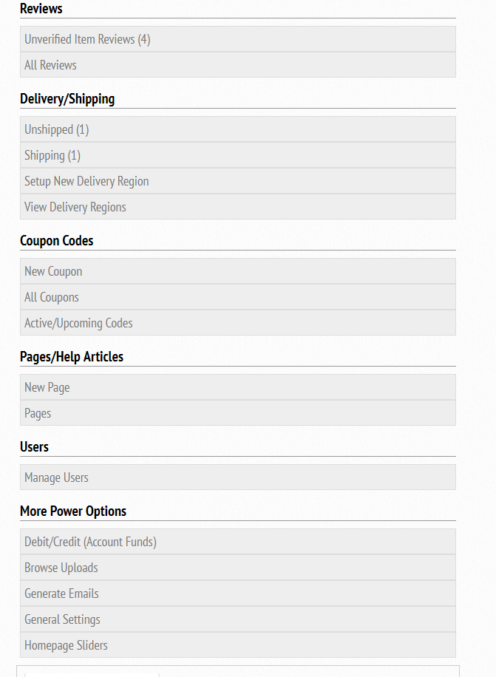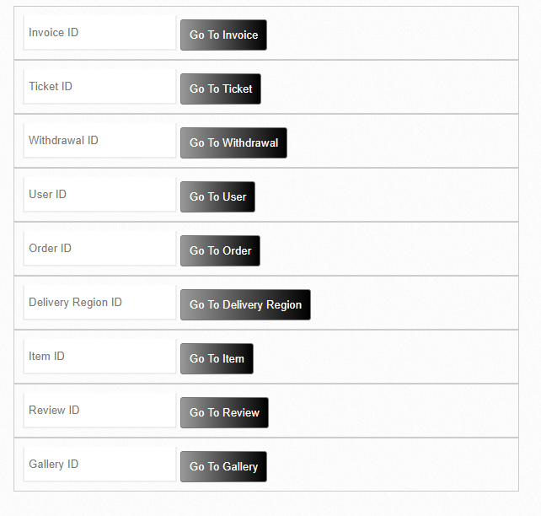

That’s an overview of the admin dashboard. Don’t get scared if you do not understand what each of those tabs does. That’s why we are just getting started and we shall guide you step by step on how to setup your new store. Just know how to return here by clicking on the admin dashboard.

Setting up Categories
For a new store, we assume you might want to make products easy to discover by categorizing them. But we have to create categories. Categories are names that hold similar or related products. A product can have more than one category. You can have a category under a parent category – this is called sub-category.
To setup a new category, look at the screenshot that we have a of the admin dashboard. Look at the section for items. Locate View/Edit Categories. By the right, you will find New Category.
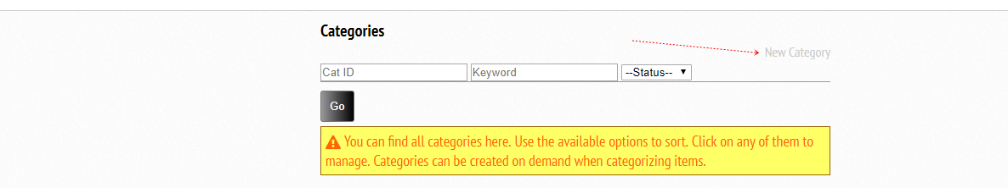
After you have clicked on it, you will find the screen below.
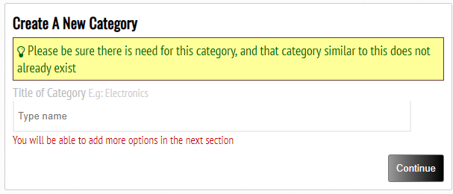
Title: Simply type the name of the category, making sure that you have not created a category like this before. Click on continue and this category will be created for you with default features. The screen that you will see, is also what you shall see when you want to edit an already existing category.
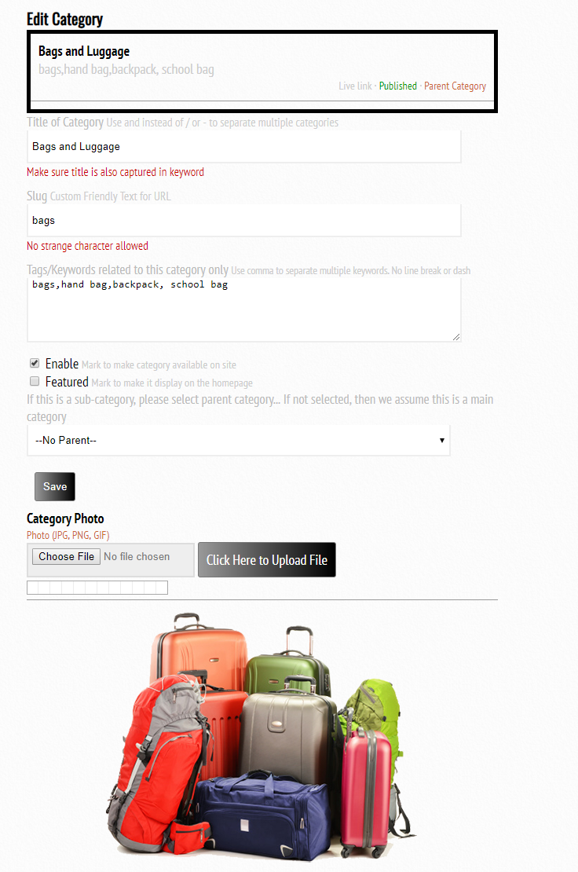
Title: Title of category is where you can always edit the name of a category.
Slug: Slug should not be touched. If you wish to edit the slug, make sure it starts with an alphabet (a-z). It cannot contain space or any other character except alphabets (a-z), numbers (0-9) and dash (-). This slug is used to generate friendly url for categories. You can easily find a category by visiting the web-address yoursite.com/category/slug
Tags/Keywords are needed to make sure that products that belong to this category are easy to tag. You will get to find out when creating products. Please make sure category name and other similar names are added to the keyword. Each term is separated with comma.
Enable is a checkbox that should be ticked if you wish for this category to be available on the website. If you are still contemplating, leave it as unticked.
Featured are used to specify that this category is special and should be ranked top in the front-page. You may have several categories and we cannot display everything on the homepage. But featured are at least shown first.
Sub-Category: Remember that we can have categories under another category. If this category is a sub-category, then locate its parent in the drop-down and pick it. If nothing is picked, we shall assume that this is a main category.
Click on Save button after you are done with this, to save changes.
You can add a photo to a category to make it look good on the front-page. Use the upload button at the bottom to do that.
When you have enough categories that look good, below is how your front-page should display them.
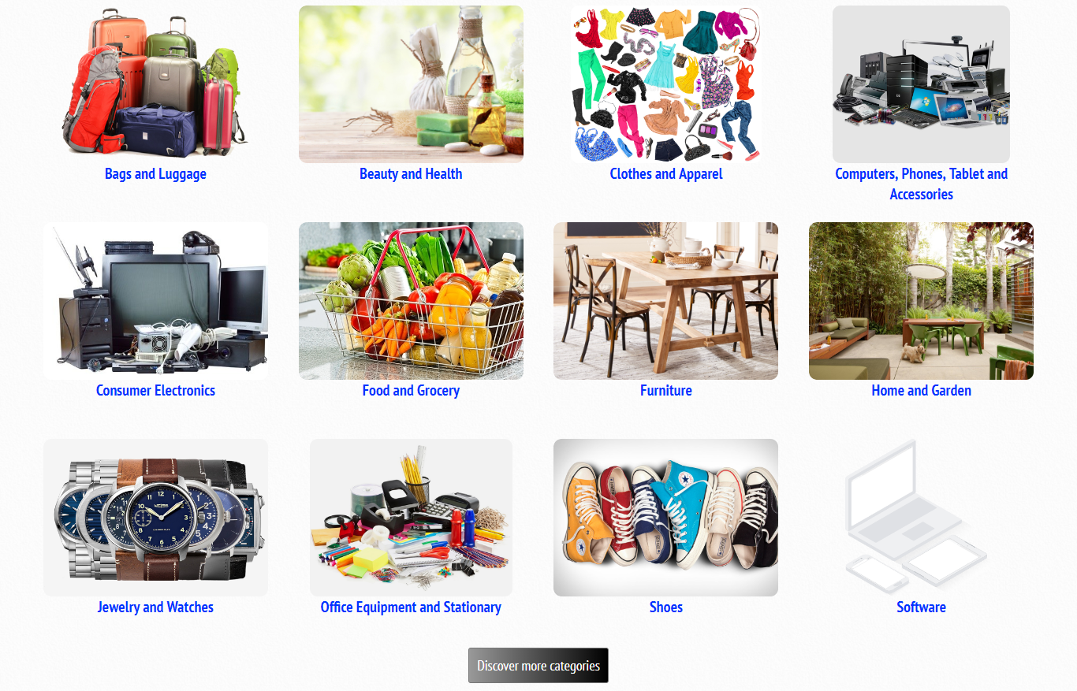
To locate a category to edit, click on Admin Dashboard. Locate the Items section. Locate the Edit/View Categories tab. Click on it and you will see a list of all available categories. There are fields that you can use to sort them. Click on Edit Category to edit any of them.
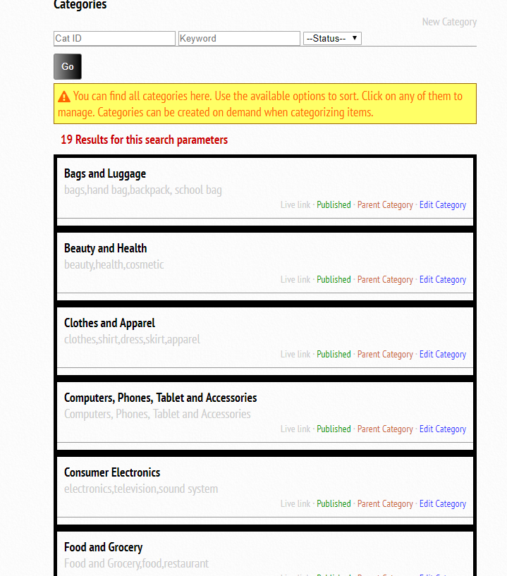

Setting up Brands
For a new store, we assume you might want to make products easy to discover by categorizing them according to the manufacturers - brands. But we have to create these brands. Brands are manufacturer names such as Samsung, Apple, Google etc. A product can have more than one brand.
To setup a new brand, look at the screenshot that we have a of the admin dashboard. Look at the section for items. Locate View/Edit Brands. By the right, you will find New Brand.
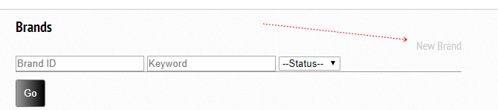
After you have clicked on it, you will find the screen below.
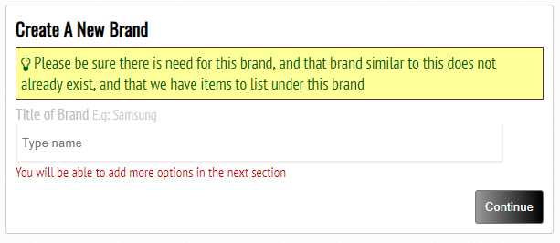
Title: Simply type the name of the brand, making sure that you have not created a brand like this before. Click on continue and this brand will be created for you with default features. The screen that you will see, is also what you shall see when you want to edit an already existing brand.
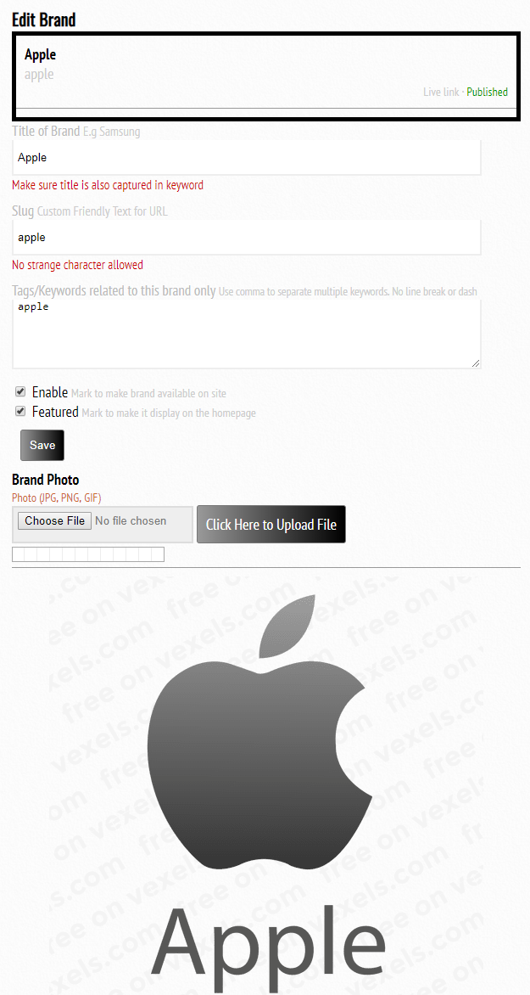
Title of brand is where you can always edit the name of a brand.
Slug should not be touched. If you wish to edit the slug, make sure it starts with an alphabet (a-z). It cannot contain space or any other character except alphabets (a-z), numbers (0-9) and dash (-). This slug is used to generate friendly url for brands. You can easily find a brand by visiting the web-address yoursite.com/brand/slug
Tags/Keywords are needed to make sure that products that belong to this brand are easy to tag. You will get to find out when creating products. Please make sure brand name and other similar names are added to the keyword. Each term is separated with comma.
Enable is a checkbox that should be ticked if you wish for this brand to be available on the website. If you are still contemplating, leave it as unticked.
Featured are used to specify that this brand is special and should be ranked top in the front-page. You may have several brands and we cannot display everything on the homepage. But featured are at least shown first.
Click on Save button after you are done with this, to save changes.
You can add a photo to a brand to make it look good on the front-page. Use the upload button at the bottom to do that.
When you have enough brands that look good, below is how your front-page should display them.
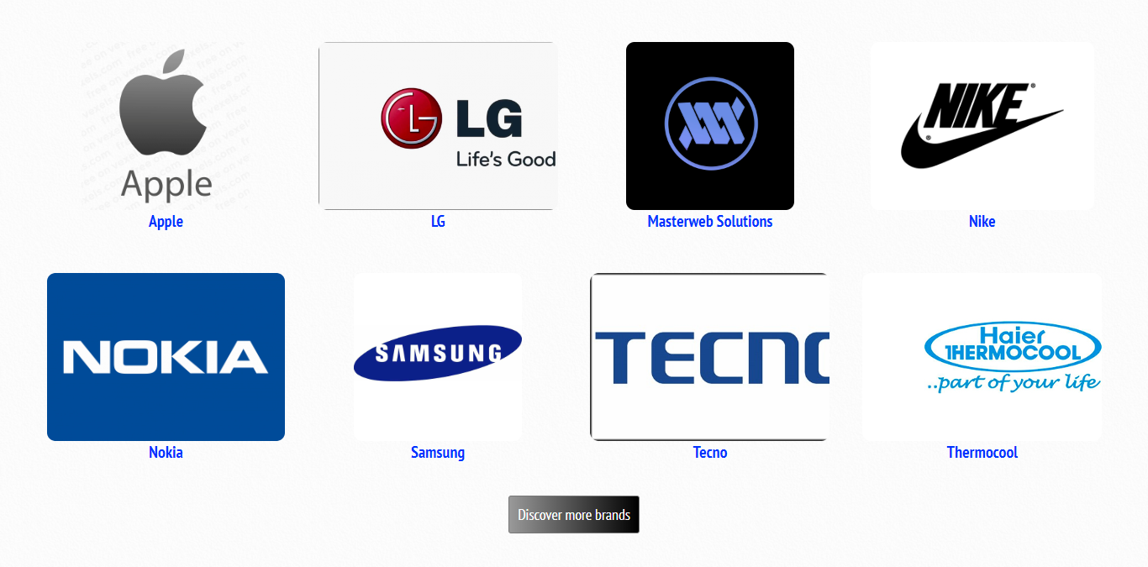

To locate a brand to edit, click on Admin Dashboard. Locate the Items section. Locate the Edit/View Brands tab. Click on it and you will see a list of all available brands. There are fields that you can use to sort them. Click on Edit Brand to edit any of them.
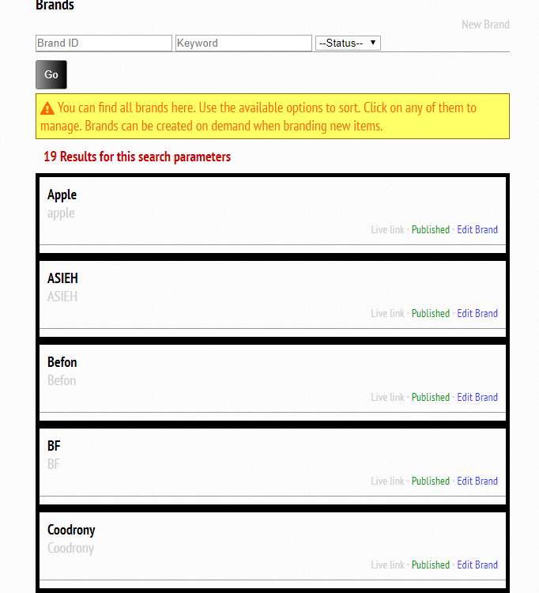

Products and Items
Now that you have setup brands and categories, we shall head to setting up actual products. We call products items. We do this because we classify products only as tangible items that can be shipped e.g Computer, Phones etc. We classify service as non-tangible items but might still have shipping cost because the person offering the service might have to visit the buyer to deliver the service. Example: Painting, Writing, Electrical Maintenance etc. We classify digital as non-tangible items that can be downloaded without a need for the buyer and seller to meet face to face. Digital items therefore have no shipping cost and are processed automatically, immediately they are paid for.

Setting up Items
To setup a new item, click on Admin Dashboard. Locate the Items section. Locate the New Item tab.
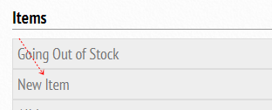
After you click on it, you shall see the screen below
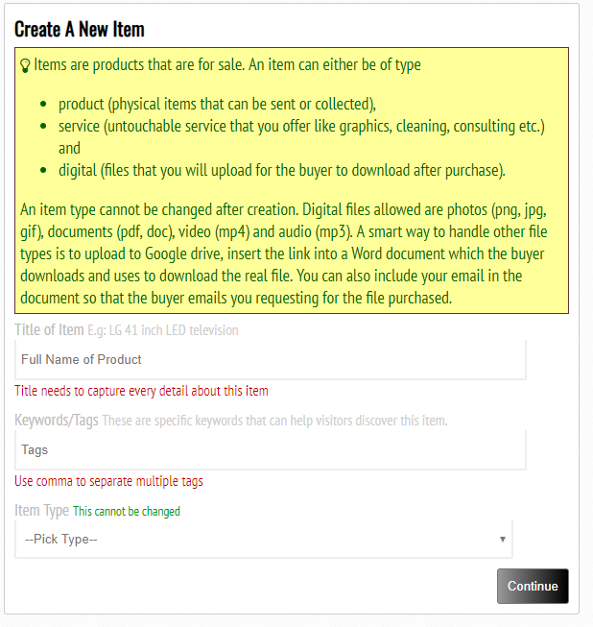
Title is the full name of the product. Make sure that you attach the brand name if product is branded. Major features should come in the product name such as model and manufacturer or size.
Tags are important to make it easy for people to discover product easily. Brand should be typed in the tag. Other variations of product name should also come in here. E.g TV, Television, Home theatre.
Item type: The right item type should be picked because this cannot be changed. Item types are already explained above – products, services and digital items.
Click on continue to proceed. This item shall be created for you with default features. The screen that you will see, is also what you shall see when you want to edit an already existing item.
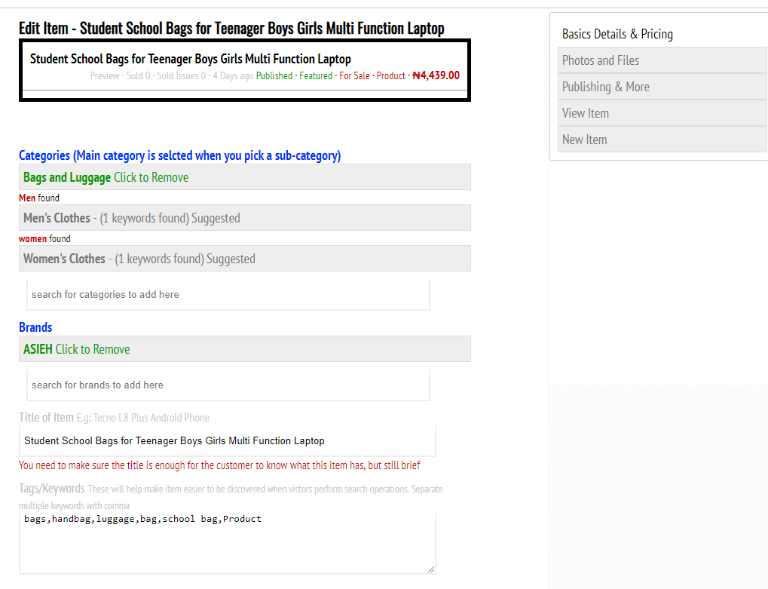
Notice from the sidebar that you are currently editing Basic Details and Pricing. After you are done, you can save and go to Photos and files where you upload item cover photo, gallery photos and then the digital file being sold if this is a digital item. Publishing and More is the section where you activate key features and then publish a product.

Basic Details and Pricing of Items
There are a lot that we can edit in Basic Details that it really needs to be its own section. So let us grab the screenshots of everything that you can do on it.
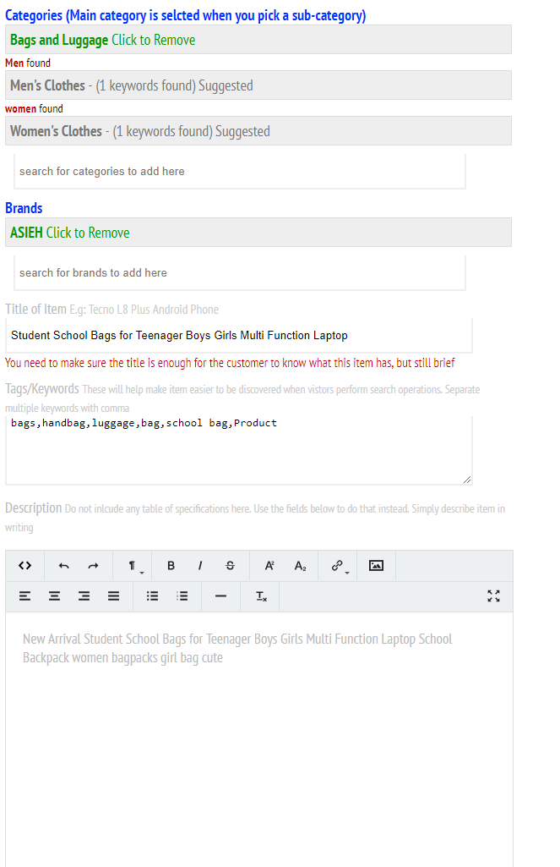
Categories that this item might fall into are suggested. If they are correct, just click on the category name and it is tagged in green. You can always click on it to remove as shown in the screenshot. You can also manually type the name of a category and then click on it to tag it to this item. If the category does not exist, you will see an option to create it immediately. When you create a new category, you also have to tag it to this item if you wish. You should also remember to visit the category section already treated to add photo and keywords to the category later. Of course, you are already told here that when you pick a sub-category, the parent category is automatically tagged for you.
Brands work just the same way as category already described above.
Title is the actual title of the item/product
Keywords are already treated while creating item.
Description contains all text information that you wish to add to the item page. This part is compulsory to give the buyer an overview of what to expect when this item is purchased.
Still on this same page, we get to the specification section where we list the specifications of the item. Look at the screenshot below
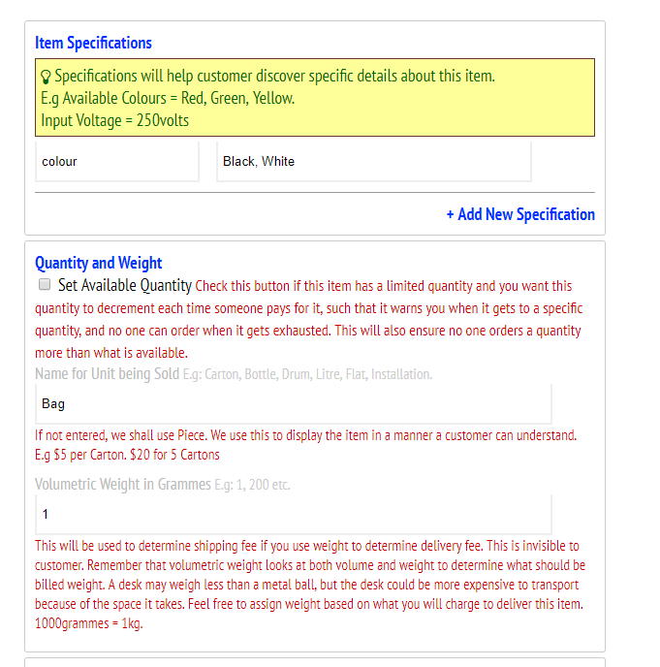
Click on Add New Specification to add a new line. You can add up to 100.
For quantity and weight, this might be useful when you have a limited quantity available and you want to people to be able to order not more than is available. There is still a possibility of customers over-ordering here because the quantity is reduced only after payment is confirmed.
When quantity is being controlled, decrement of quantity happens only when payment is confirmed. This means that some orders already placed when quantity has not been reduced but not paid for will eventually cause more orders than the quantity merchant budgeted for, assuming they are paid for. When this happens, customers are refunded. Of course, these are to be stated in your conditions.
When you click on the Set Available Quantity button, you will be able to set the quantity available, and also be able to set the quantity item will get to before you are warned on the Admin dashboard. When quantity gets to that level, there is a warning on the admin dashboard. If there are 3 items going out of stock, the number will be shown in bracket under items. Going Out of Stock (3)
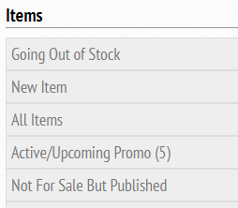
Name of unit being sold is for the common name of the item. Assuming it is a bag of cement, this should be bag. Assuming you are selling a trailer load of cement and a unit quantity represents one trailer load of cement, then this unit name should be trailer. We can have packet, box, basket, phone, litre, gallon etc. This will make sense when displaying quantity for the buyer. E.g A phone costs XXX amount. If you wish to order more than one phone, please enter quantity here. If this is not entered, we use piece.
Volumetric weight in grammes is used to calculate shipping cost during checkout. More details about how this is done will be treated in the shipping/delivery section. Only whole numbers are allowed in this section.
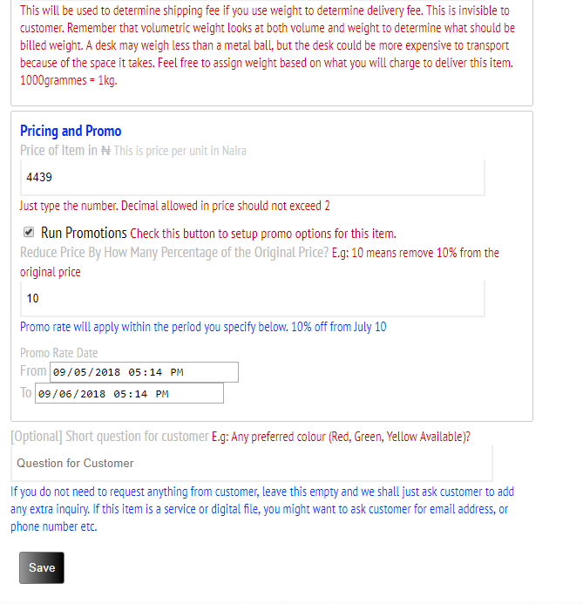
Now to the pricing on promo section of this basic details, we need to specify the price of the item.
The price is can contain floating point number, up to 2 decimal places.
If you wish to run a promotion where discount is offered for a limited time, just click on Run promotions and the sections below it will drop.
Enter the percentage discount. This is the percentage of the original amount that will be slashed off during the period that will be specified.
Use the From and To field to select the date and time of when promo starts and ends. If start date is in the future, then promo is upcoming.
Optional question makes sure you can manually request extra information from customer. Just keep it brief. Assuming you are selling a phone and you have many colours available, you can ask the customer to pick a colour here, while stating the available colours. You can use this option for a lot of things.
Click on save button to save all the changes that we have made to this section.

Photos and Files Section for Items
When you locate the section from the sidebar and click on it, you should see a screen similar to this
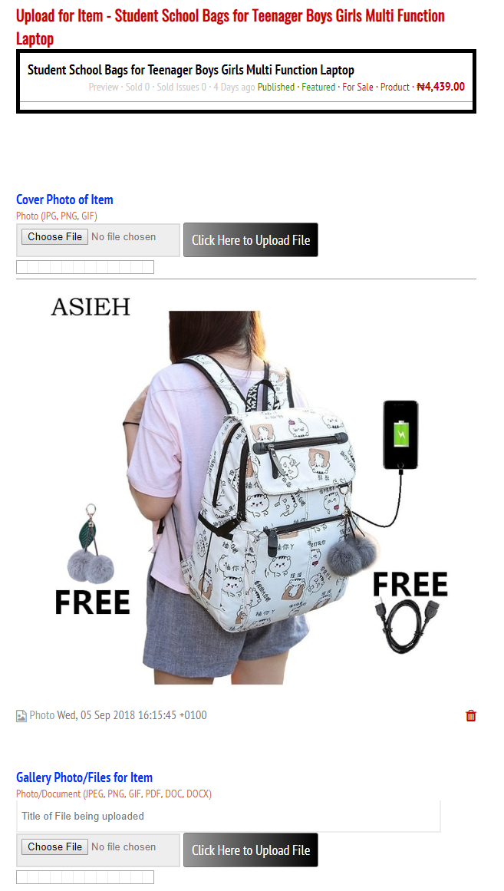
Only one cover photo is needed. Cover photo is the main photo of the item. Make sure you pick an attractive photo that clearly shows the product. A square photo will look best. Transparent background is the best, but white or black background works too.
Gallery Photo/Files for Item can accept up to 30 photos of different views of the item. This is optional.
If this item is a digital file, you will see another section here to upload the files that are to be made available to the customer after payment is confirmed.

Publishing & More Section for Items
When you locate the section from the sidebar and click on it, you should see a screen similar to this
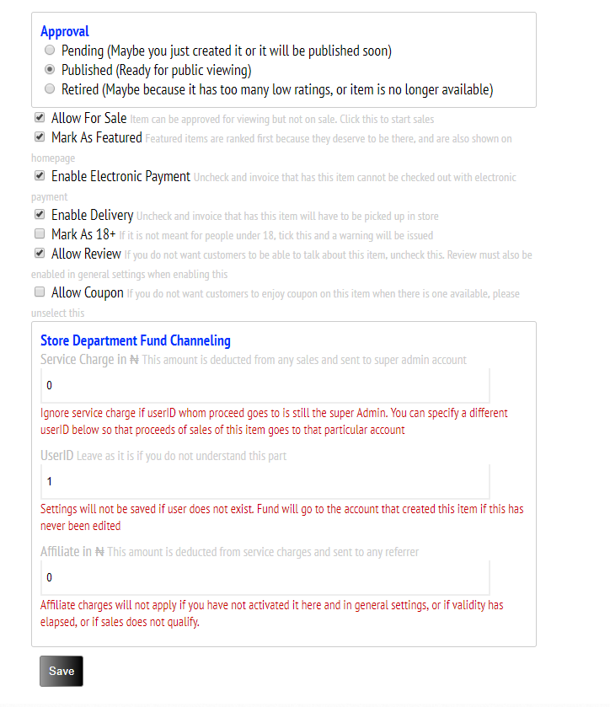
The approval must be set to Published for this item to be available to customers. This means customers can view it. There is an Allow For Sale section that makes it available for purchase.
Allow For Sale must be ticked for customers to be able to purchase this item. If not, they can view it, but will have no way to place orders.
Featured items are shown first on the homepage. So only mark items as featured if you wish to feature them on the homepage.
It is possible that some payments gateways will have a commission of 1% which might be negligible for little items, but for items of very high value, this 1% could be your profit margin. You might want to use bank payment where commission does not apply to accept payment. Then you can untick this option to make sure electronic payments are not enabled for this item. Customers are warned that they can only make payment with their account funds and bank payment.
Delivery is automatically enabled for items. If you cannot ship this item, maybe because it is bulky, or for whatever reasons, simply untick this Enable Delivery and this item will not be able to ship. Customer only has an option of purchasing and coming for collection.
Some items that are not suitable for people under the age of 18 are identified when this button is ticked. Customers are warned when they are on the product page.
When review is enabled for an item, then customers can review it.
When coupon is allowed for an item, the customers can use a valid coupon code on them and they will be able to get a discount offer. This does not stop discounts activated in price section for this item.
Store Department and Fund Channeling is created to make store and fund management easier for the merchant. Merchants can create many accounts and forward funds received from different items to different accounts. For example, all sports equipment proceeds might be forwarded to account ID 2 while proceeds from foods and grocery items are saved in another account. Account IDs are found from the customer section which we shall treat in coming chapter.
There might also be a cost of selling some items which merchant will want to send to the super-user account. This service charge is specified here.
If affiliate is activated, merchant can specify the amount to pay affiliates. This amount is part of service charge and is deducted from service charge. Therefore, if you wish to pay affiliate referrers 10USD per item sold, you will have to make sure service charge is equal to or greater than 10USD.
Click on save and you should have completed the process of creating an item. On the front-page, items should be displayed as follows
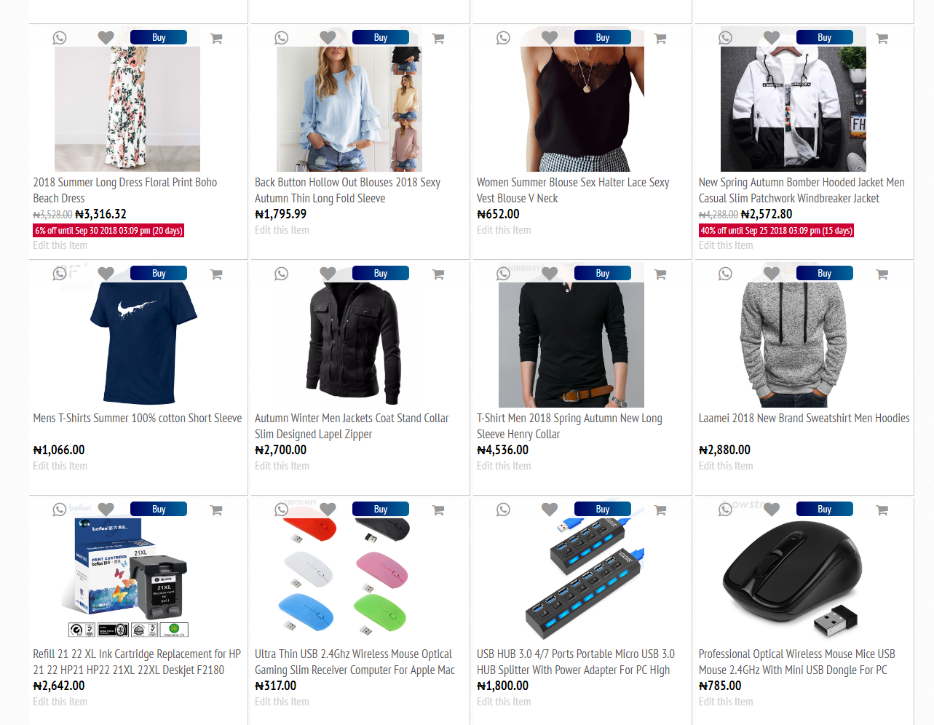
Where list view is used, it should be displayed as
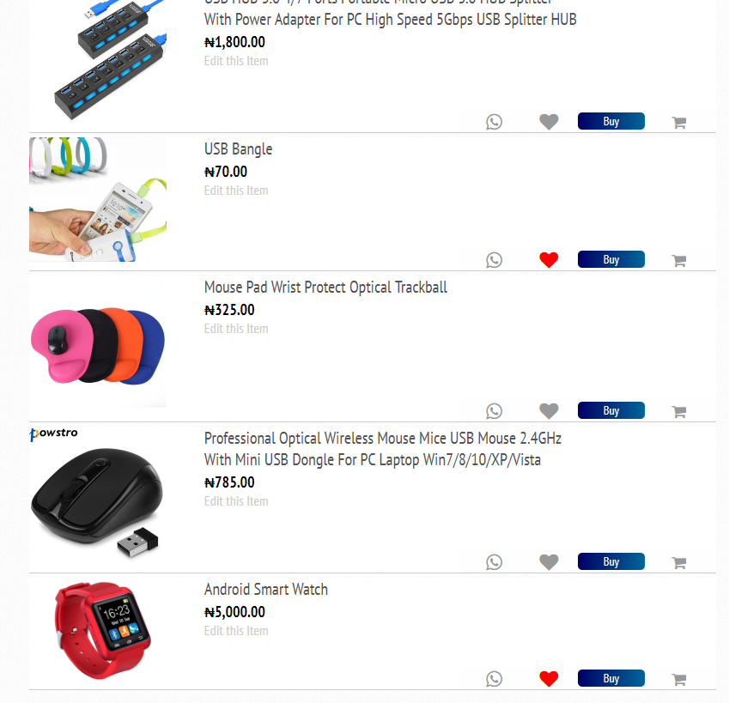
And a standard item page might look like this
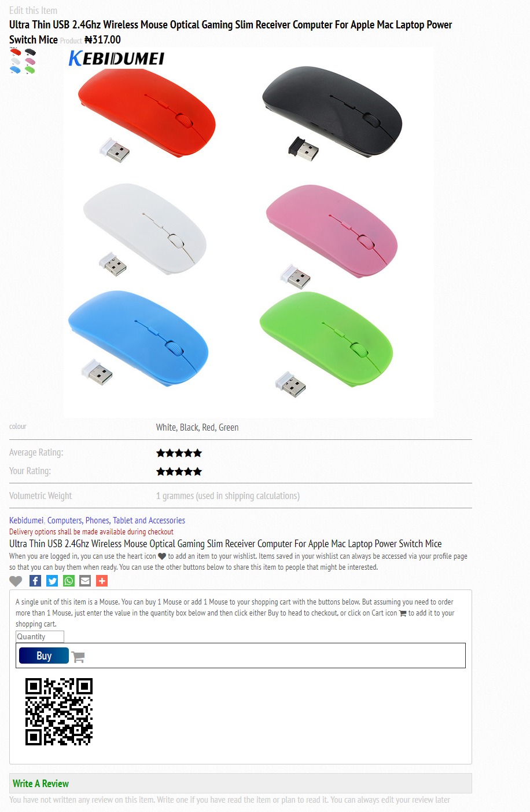

Locate an Item for Editing
To edit an item or to find a list of all your items, just click on the dashboard, locate the view items and click on it. Then use the available options to filter the items you need to view. Click on edit item to edit.
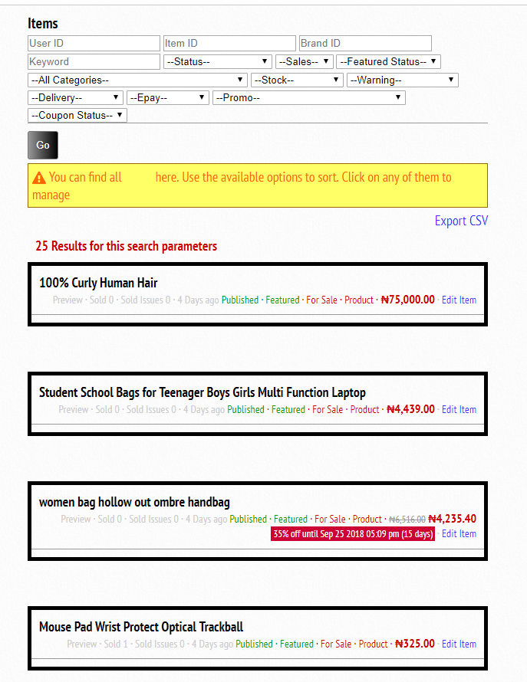

Setting up delivery options
You can enable or disable shipping from general settings. But assuming shipping is enabled, and you want to give your customers estimates on what you will charge to ship the items they buy to different locations, you have to consider setting up several shipping options. Go to your dashboard and locate the section for Delivery/Shipping. Click on Setup New Delivery Region. You can setup 2 similar regions but with different offerings. For example, you can setup a shipping region for London but one delivers in a day and is more expensive while the other delivers in 7 days but is less expensive.
When you get to the screen for setting up a new delivery region, you will find the screenshot below:
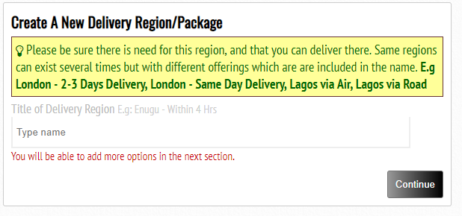
Type the title of the region. If you will have different offerings for the same region, please append the extra offering in the name, as seen in the example in the screenshot above.
Click continue and the delivery region shall be setup for you with default details. The next screen you find is similar to what you will see while editing an already existing shipping region.
There are 4 options that can be used while setting up a shipping region.
- Flat fee settings: when a specific amount is charged everyone
- Weight based fee: where volumetric weight of the item is considered and then added to a fixed amount
- Free with conditions: where you offer free shipping when customer spends up to a specific amount and weight less than a certain level.
- Free unconditionally: I don’t think I need to say anything more on this – FREE SHIPPING.
The tricky part is that you have to configure a cost for the 3 fee-based just in case you wish to switch to any option later. But you only have to pick one. When option 3 is used but customer does not qualify, then option 2 settings is used.
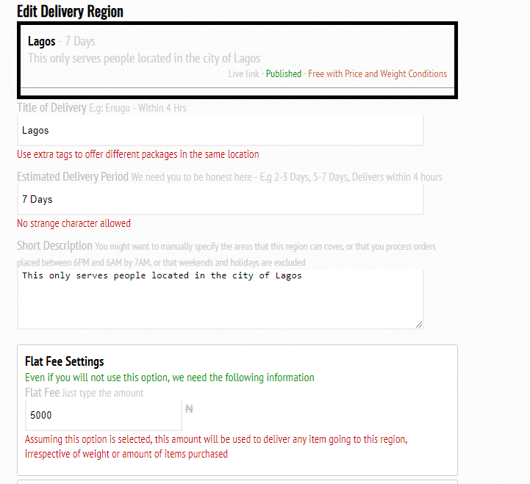

The same rule that applied while creating a shipping region title still applies here. You can edit the title if you wish.
Enter the estimated delivery period. E.g 4-12 hours, 5-7 days, 2-3 months.
Briefly describe this shipping region to avoid confusion. Some customers whom it does not cover their area but it is close to their area might use this, thinking that they are covered. If there is a certain area you wish to exclude, you need to state it clearly here.
Now to the shipping options. Even if you will not use a flat-fee based pricing, just type the amount you might charge assuming you are compelled to use this option.
Now, let us jump to the other options available in this section below.

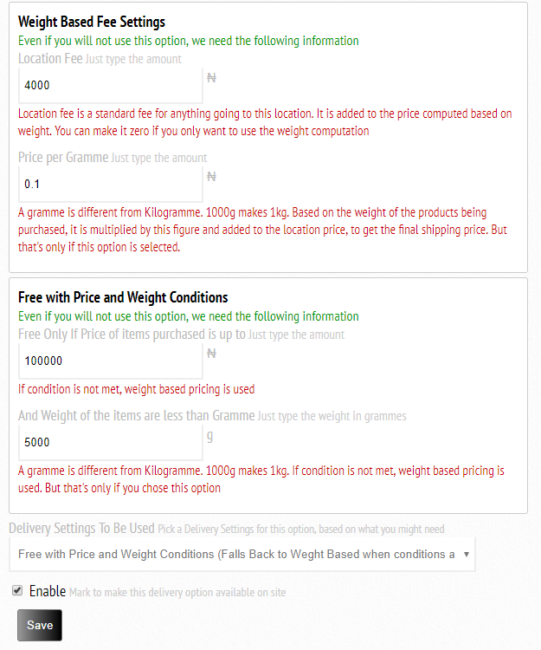
Weight based fee settings must also be setup even if you do not wish to use this option. The calculation for weight based will be based on the amount you are willing to charge per gramme + a fixed price.
The fixed price might be zero, but I’m sure some locations may have a cost of transporting even a letter that might weigh less than 1 gramme. Setup the location fee which is the fixed price.
Setup the price per gramme, which should always be in decimals, unless you are shipping to Jupiter.
Now, you also have to setup the option for conditional free shipping. You will ship for free when the total cost of items purchased is up to the amount entered in the first field, but the weight has to be less than the number entered in the second field. When this option is used, but customer does not meet the conditions, then it defaults to weight-based settings. You see why we needed these two configured, even when not in use.
The next drop-down is where you pick the option you want to use. Pick the delivery settings, taking note that you should pick Unconditional Free Shipping if you are running a promotion, or if this region is very close to where you operate from, or when you want to use Free shipping as a selling point.
The checkbox should only be checked when you wish to enable this shipping option for customers to find it during checkout. Remember that when shipping is disabled in general settings or in item settings, customers will not be able to use any of these options during checkout. We shall still get to general settings.
Click on save to finish this setup for delivery. To edit any delivery region, just scroll to the dashboard delivery section and locate View Delivery Regions. Click on it and find the screen below. Just click on the Edit Delivery to edit.
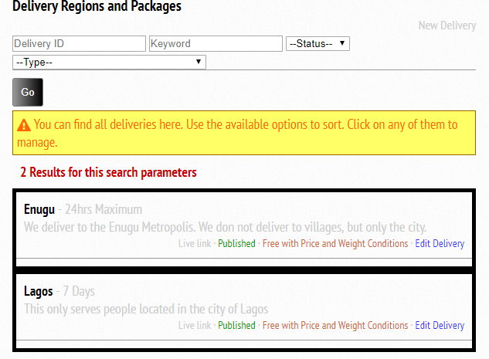

To test different delivery options, just go to the footer and click on the delivery options, or from the screenshot above, click on the Live link. You will see a page where you can type in any amount of purchase and weight to view the costs for different regions that have been setup.
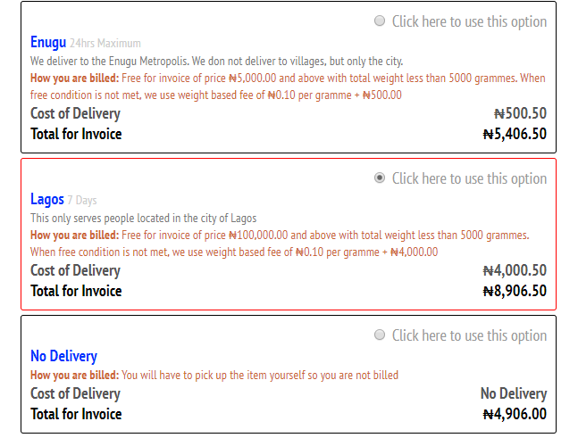

Setting up Coupons (Promotional Codes)
Promotional Codes, also known as Coupons, are a great way to market a product. MS has a great coupon system where you can setup promotional code to work on every item you have coupon enabled for, setup coupon codes to work on only specific items, or setup coupon code to work only on a single item, all for a limited time you have chosen.
You can do some googling if you are in doubt how coupons can help your sales. Setting up coupon codes are similar to what we have been doing with every other setup. By now, you can even do this yourself without guide if you have been able to setup delivery regions, categories, brands and products. But for the sake of clarity, let us teach.
Scroll to the coupon section of the dashboard. Click on New Coupon
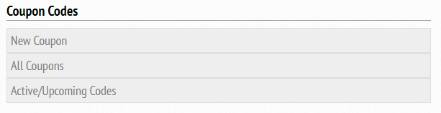
Then you will be shown a screen like the one below
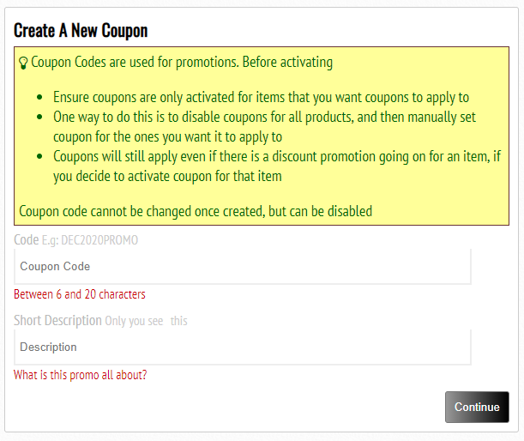
Coupon code names are always suggestive. Look at that DEC2020PROMO for example, it suggests something. Do not make it so easy that customers can guess coupon codes, but make it so easy to understand when they look at it. Coupon code names must start with an alphabet, and not a number. It must also be between 6 and 20 characters and cannot be edited once created.
You can add a short description that the customer will not be able to see, but at least that makes you understand the problem that coupon code came to solve.
Click on continue and the next screen is just similar to what you see when you edit coupon codes. The new coupon is already setup with default details.
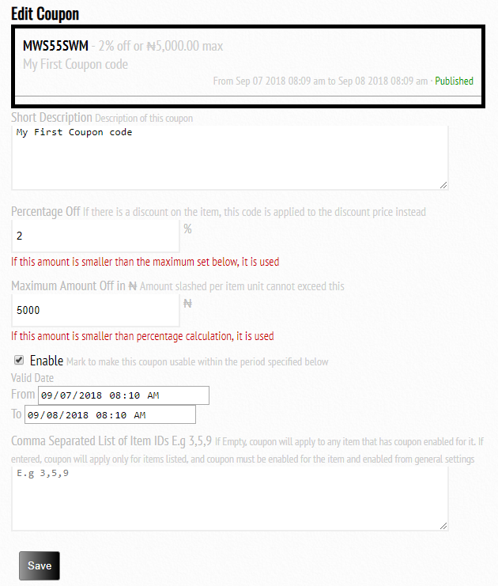
The short description has already been described during creation
Percentage off is the percentage of the cost of the item you wish to slash off when this coupon is used. If there is already a discount promotion going on for the item, this slash is applied to the discounted price.
Maximum amount ensures the coupon saves not more than this amount per item per unit of whatever it is applied on. Therefore, maximum amount only applies when percentage off computation goes above the maximum allowed.
Enable coupon when you want it useable. If you do not enable it, it will not be useable. Additionally, coupon must be enabled from general settings, and then enabled for each item before it can be used on that item.
Coupon validity date means that coupon can only be used within the date and time specified between the From and To fields.
Comma separated list of items is where you can indicate list of item IDs that this coupon should work on. If nothing is specified here, then coupon can work across any item with coupon enabled for. To fetch an item id, please go to the item section browse. You will see the item id for any item you open.
Click on Save to save this coupon. Coupon Codes are applied during checkout.
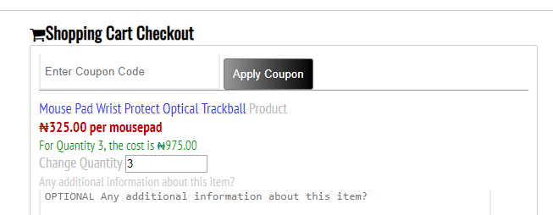
To edit any coupon code, just click on All Coupons from the dashboard and click on Edit Coupon for the particular coupon you wish to edit.
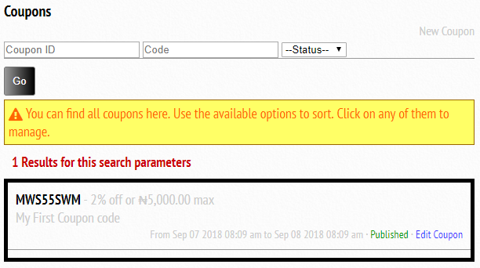

Setting Up Homepage Slider Gallery
You must have seen the photo gallery sliding on the homepage. This can be configured by you, and it is quite easy. You can also make the photos clickable such that it sends your visitors to a particular page in your website when they click on it.
Go to your admin dashboard and locate the More Power options
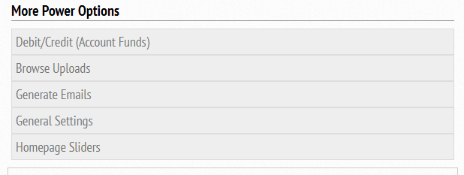
Click on the Homepage Sliders. You will be brought to a page where you can upload photos that will slide on the homepage.
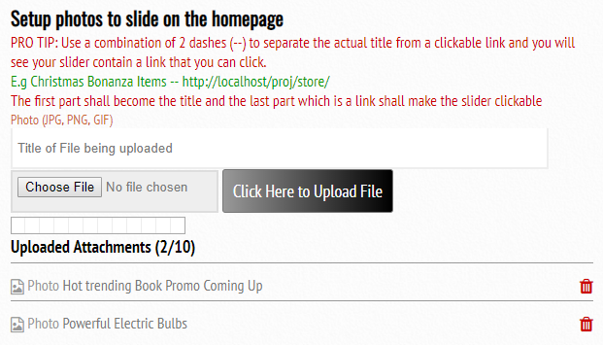
You can upload up to 10 photos. Use double slash in the photo title to attach a link. After you have done this, and photo gallery is enabled in your general settings, click on the homepage and you will find your photos sliding.
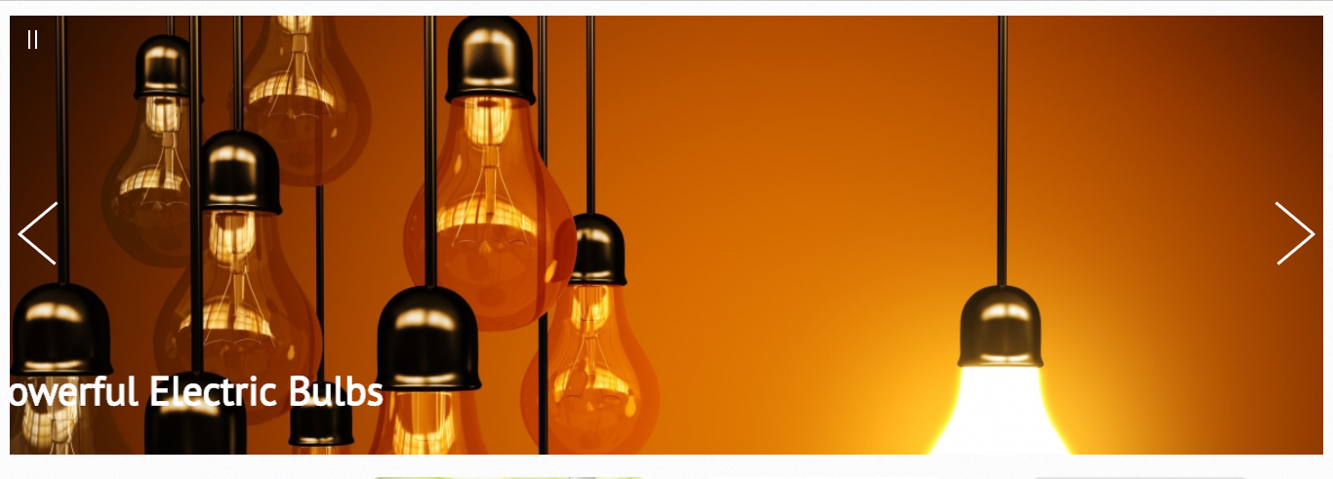

General Settings
We have been talking about this general settings, and finally we have gotten to it. Go to the More Power options section from dashboard, and click on general settings.
You will see a screen with a lot of options. Here is an explanation of what those options are, just beside each field.
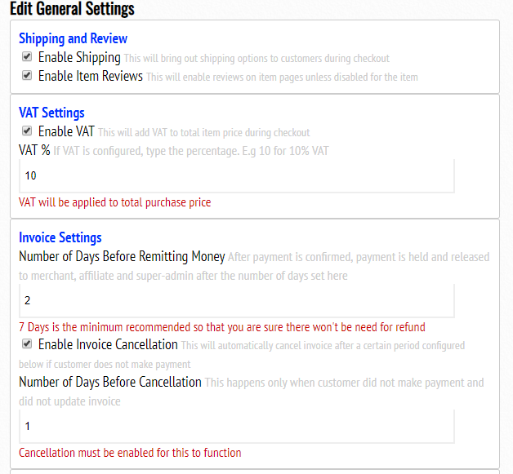
Notice that in invoice settings, we have X days remitting period. This is the period of wait after payment is made by the customer, before we send the money to the accounts that are beneficiaries. Example beneficiaries are super admin account where service charge goes to, account where the sales go to (assuming departmental fund channeling was setup for the item) and affiliate earnings. It is recommended that you use the number of days from which you will not be able to entertain any refund request. This is because you might have to manually deduct money from various accounts if money has been remitted to them already, and you need to refund customer for whatever reasons.
But if the number of days used is long enough, remitting will be final since the return policy period would have elapsed.
Invoice Cancellation section automatically cancels an unpaid invoice if customer does not make payment after a certain period of time. You can disable this if you wish, but note that this means that customer might decide to make payment when the price of the item has gone up but invoice generated was at a very low cost which might cause you to run losses. 24 hours which is a say is recommended.
Find the rest of settings available in general below.
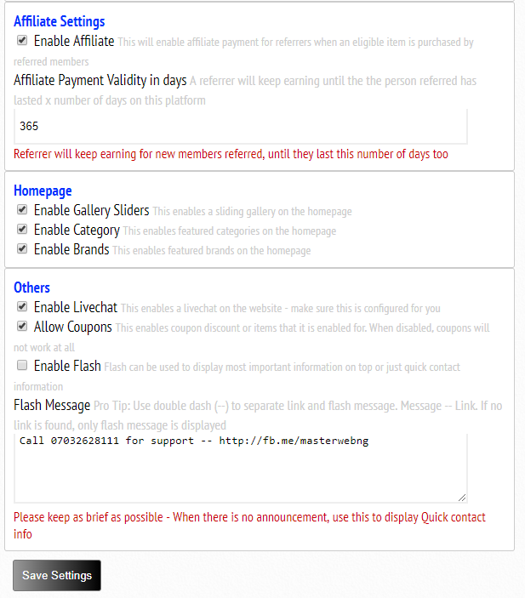

Pages/Articles
Content Management System is an important part of any website. You can manage write-ups here through the Pages/Articles section of the dashboard.
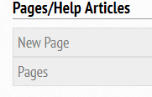
You click on the New page to setup a new page, or click on pages to browse existing pages. When you click on new page, you are brought to a screen similar to what you find below:
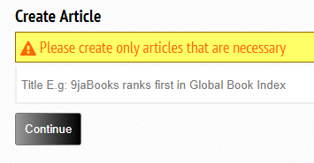
Type the title of the article and click on continue. The next screen is similar to what you will find assuming you are editing an already existing article.
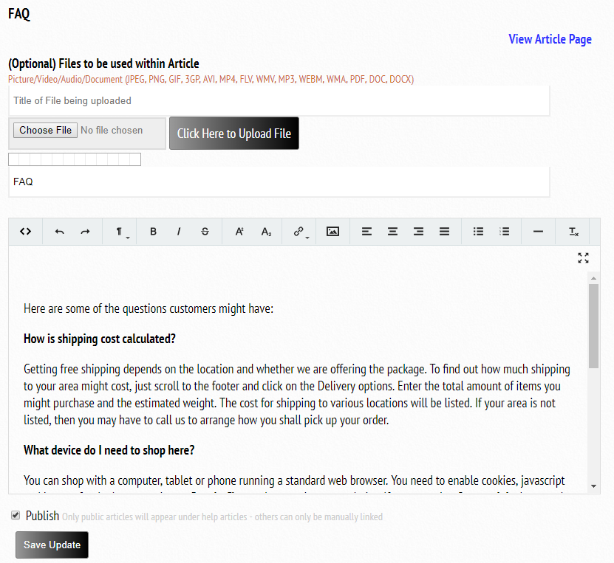
You can add files and photos to the article through the upload button above. You can edit the title of the article from the field for title. You can type the full details of the article in the rich text field above.
The publish button should be clicked if you want your article to be publicly available through the Help Articles link on the footer.
You do not need to check the publish button for the following pages already created for you: About, Contact, Privacy Policy and Terms/Conditions, Homepage Intro. These pages are always publicly available.
Click on Save Update to save.
To view already existing pages and edit, simply go to the Article section on the dashboard and click on Pages. Locate the article you wish to edit and click on it
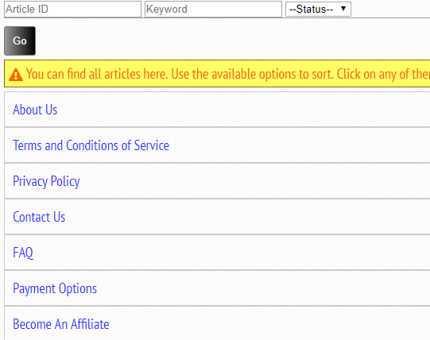

Managing Masterweb Stores
Managing Masterweb Stores is very easier than setting it up. Simply follow the rest of the tutorials to manage support tickets opened by customers, manage invoices, orders, withdrawals and members, alongside anything else.
One important thing to note is the difference between invoice and orders.
When a customer shops, there might be many products in the shopping cart. To pay for them at once, we use invoice to create a payment request for the customer to pay. Once payment is made, the invoice is considered paid for. An invoice can contain a single product or multiple. VAT and Shipping cost are also calculated in the invoice so that payment is made once. As a merchant, you have to process invoices that have been paid for, so that customers can get their items delivered.
For accounting purposes, we remit every item in the invoice into orders once they have been paid for. When a customer had 10 items in an invoice but wants refund for one item, it is at the order level that you can find this specific order and refund the customer only for that single item, without any need to touch the invoice. Invoices are split into orders after payment is made. This means that you can find orders of exactly the same item from different customers for analysis. What you can do with this, is endless.

Managing Invoices
In the invoice/order section on the dashboard, we intentionally listed a lot of filter options so that unprocessed and verifying items are put in bracket. These should keep the merchant at an alert.
Additionally, orders, invoices and withdrawals are kept in the same section as seen below.
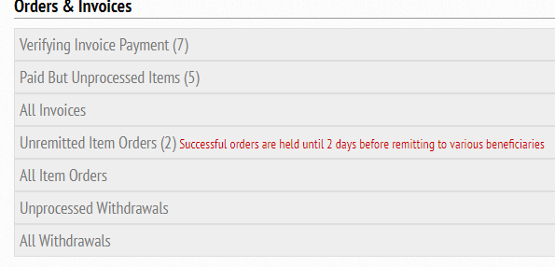
When a customer has generated an invoice and paid for it, you should be able to find such invoice via the Paid But Unprocessed Items tab. You should click on it and locate the invoice to process it. When a customer claims to have paid through a method that does not automatically confirm, you need to manually verify the payment method and mark the invoice as paid. Those kind of invoices can be found in the verifying invoice payment tab.
Irrespective of filter options chosen, they all end on the same page where you view all invoices. You can manually use the available filter options to view only the invoices you wish to see. The page is as shown below.
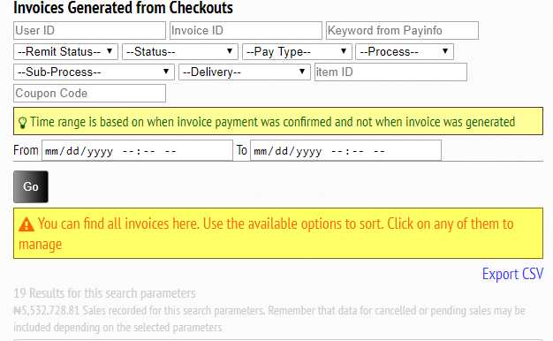
There is an Edit as Admin button under each displayed invoice. This is where you need to click.
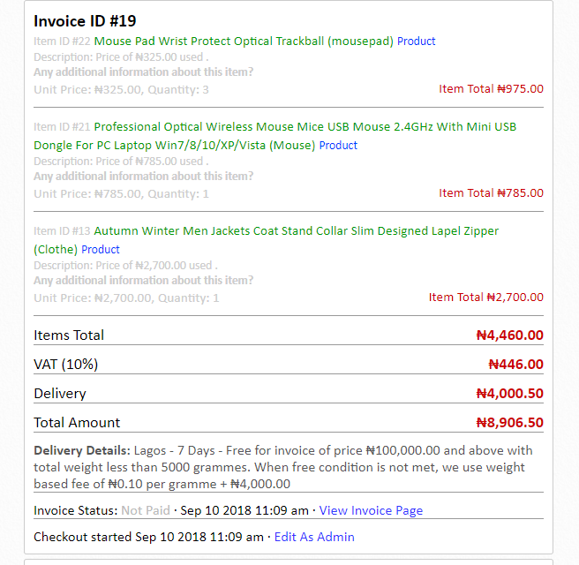

When you click on edit as admin. There are 3 things that you can do. Edit the payment status, edit the processing status, or assign the invoice to another customer (we are assuming you can generate invoice for a customer who is in need of help on how to generate invoice or for whatever reasons that you might want to do this).
This is a sensitive area, so most of the changes done here might require you type your PIN.
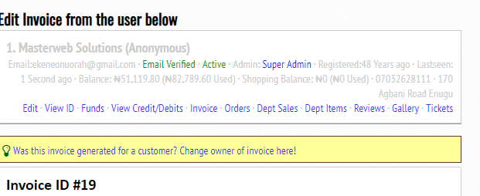
If truly this invoice was generated by you for a customer, you can use the link in the yellow tab above to change the owner. You must know the customer ID to be able to do this. We shall still come to that part.
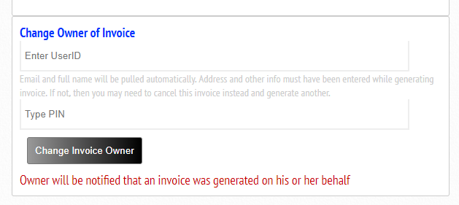
Enter the user ID (userID, customerID and accountID are the same thing and could be used interchangeably), then enter your PIN and click the button. The new owner will be notified that an invoice has been generated on his or her behalf.
However, if your goal was to process an invoice and not to change its owner, scroll down from the Invoice Edit page.
You will see the sections below.

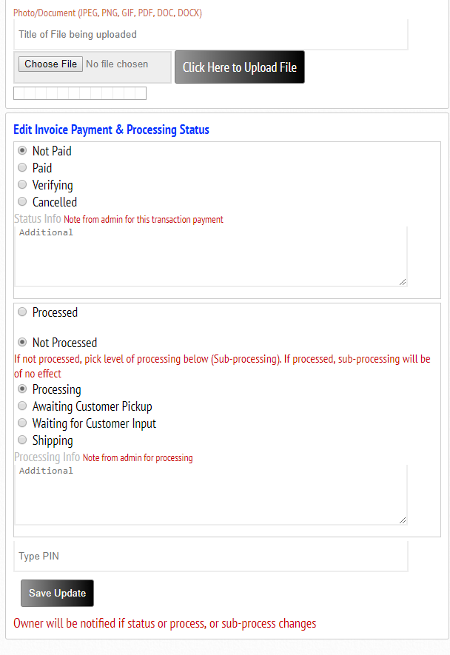
You can upload any file for the customer to see. This could be evidence that you did not receive the money or that the money was not paid completely. Customer from his or her own end can also upload attachment that you will be able to see here.
If customer has made payment for this invoice and it was not automatically confirmed, click on the Paid radio button to confirm. You can use the additional field to type any reminder – maybe details of how you were able to verify that payment was made. You can also cancel invoice by using the cancelled.

After payment is confirmed, the next is invoice processing. Invoice can either be processed or not processed. When it is not processed, you can use a lot of status under the not processed to update the customer. You can see the sub-processes of Not processed which are: Processing, Awaiting Customer Pickup, Waiting for customer input, and shipping. You should also use the additional field to add more information about the invoice that you are processing.
Type your PIN and click on Save Update.
That’s all for invoice processing. But let us assume a customer needs to be refunded after invoice has been paid for, you can individually edit each of the orders in that invoice from the Item Orders.
Invoices are remitted to orders, then orders are remitted to beneficiaries. Unpaid invoice will never remit to order, unless paid. If payment status is later edited, remitted orders will not reverse. This is why refunding should be done at the order level to avoid double-refunding errors.

Managing Orders
You can click on unremitted orders to see the orders that have not been remitted to beneficiaries yet.
Remember that all orders are paid before they had to move from invoice to this order level. Each of the item can individually be edited assuming enough reasons were found to refund customer.
When any of the tabs above are clicked, there are still a lot of filter options available so that you see only the orders you wish to work on. You can even enter the invoice ID to view only orders created from this invoice.
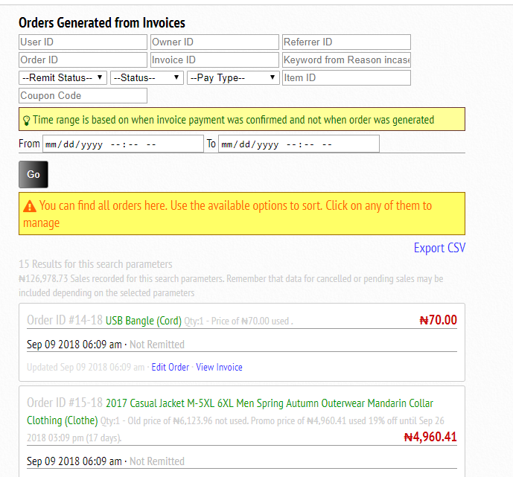
Owner ID refers to the person whom sales payment will be remitted to. User ID is the customer ID. Referrer ID is the person whom will get affiliate earnings if any is available.
To edit order, simply locate the very order and click on the Edit Order link. You can also view the main invoice that generated this order from the View Invoice link.
When you click on the Edit order, you shall find a screen similar to the one below:
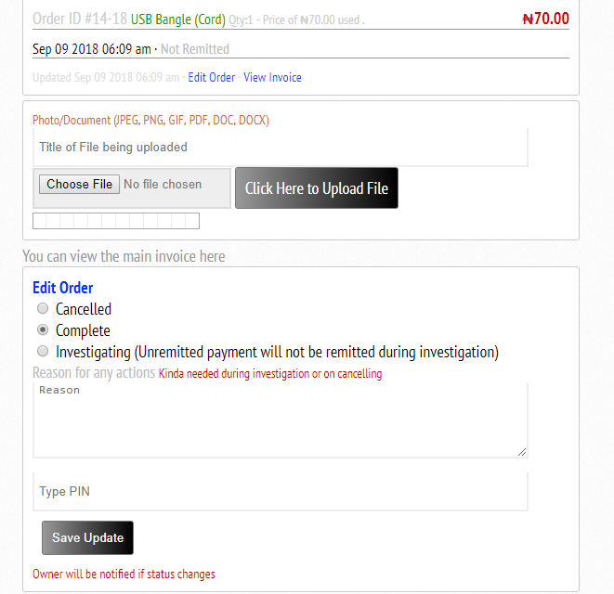
You can upload files, maybe as evidence of refund if you had to do it. Scroll to Edit order to change its status to cancelled when you will refund customer.
Leave it as complete if no issue was found. Leave it as investigating if there is an issue you need to investigate. When an unremitted order is in cancelled or investigating mode, no payment will be remitted to anyone.
You should use the reason field to type any reminder as to why you took any action on this order.
You shall see an easy way to refund customer in the user account section. There, you can add the funds to the customer’s account for shopping only, or add funds that can be withdrawn into any account of choice.

Managing Withdrawals
Customers can withdraw money for many reasons. This could be money earned through affiliate program, or rebate gotten for item received that was not up to a certain quality stated, or refunds. A merchant may also need to withdraw funds earned for various purposes such as VAT, shipping, service charges and sales of certain items. Merchant can specify different accounts where these funds are channeled to, during installation. This is configured by the developers. But accounts where sales are sent to can be set up by the merchant when publishing products.
Looking at the withdrawal is a great way to access the funds being taken out of the business. Looking at the item orders or invoices paid for are great ways to look at revenue generated.
Now, any fund found in shopping balance of any user cannot be withdrawn, but can be used to settle an invoice. But any funds from the main balance can be withdrawn.
When funds are withdrawn from the front-end, you can access the withdrawal request and process them from the dashboard.
When you click on either of these, you will be brought to a page with a lot of other filter options.
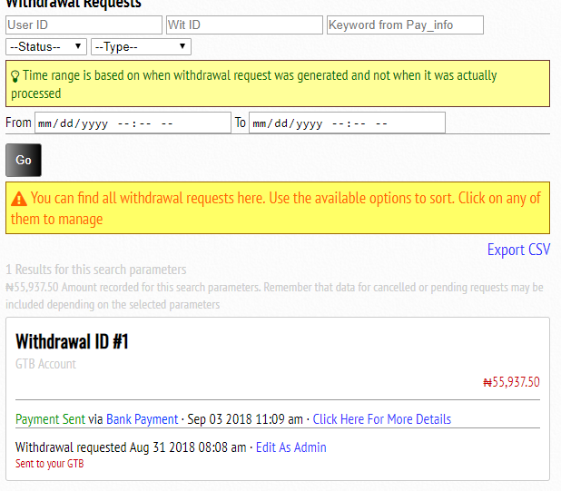
Click on Edit As Admin to process any withdrawal request if it has not been processed yet.
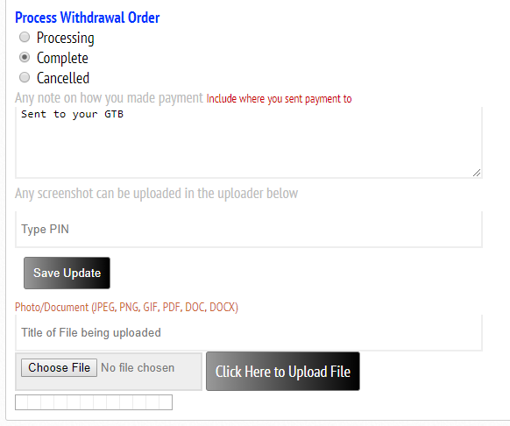
When withdrawal request is generated, its status is processing. When you cannot fulfill the request, you will need to cancel it. When you cancel, you have to manually send funds back to the customer that made this request. You will learn how to do this when managing users.
When you have made payment, or submitted request for processing offline, then you can mark as complete.
If there are any evidence you may wish to attach, you can do so with the upload button. You can also add note on how you made payment or why you will not.
Type your PIN and click on Save Update.

Managing Support Tickets
Support ticket can be opened by customers for any issues. You as the merchant can attend to customer issues by email. When a new ticket is generated, its status is unassigned and you will receive an email that you can use to reply to the customer. When you start attending to it, you can change its status to investigating. After attending to the issue, you can mark the status as Resolved.
Communications are done by email between merchant and customer. To find a new unassigned ticket, scroll to the ticket section on the dashboard and click on unassigned tickets. For other tickets, just click on View All Issues. Use the status to filter the type you wish to see.
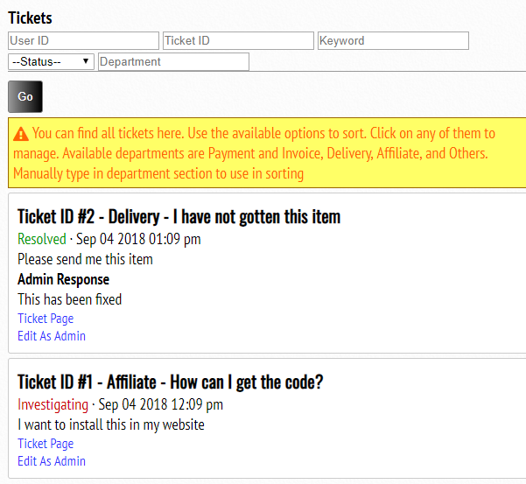
You can always see the other filter options so that you can only see the type of tickets you wish to handle at the moment.
Click on Edit as Admin to update a ticket status.
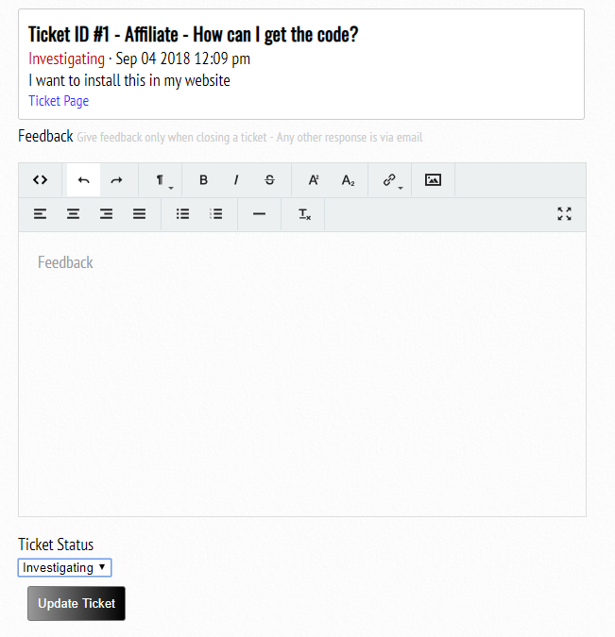
Please note that customer does not get an email from what you type in the feedback. This feedback is just a summary that you should give when changing the status of the ticket to resolved. Anything else should be in the email conversation already created between customer and merchant.

Managing Users
You have to be able to manage accounts created on your website. Customers, store handlers and even you as the merchant all operate through user accounts. Every account has an ID which we can refer to as userID, accountID or customerID. These 3 terms are the same in this context.
Customer information are not made public. Customers can pick a nickname that they can use while writing reviews. This is the name that is seen by the public.
A merchant can view everything about any user such as tickets created, invoices generated, orders, products whose sales proceeds should be forwarded to the user, and sales already forwarded to the user via orders, and uploads from the user.
Merchant can block a user from accessing the website, make a user an admin who can get access to dashboard, add funds to a user’s account or deduct funds. Merchant can also reset the account PIN for any user who has access to dashboard.
To find any user, scroll to the user section on the dashboard.
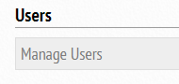
Click on it and you should see a list of users which you can equally filter based on what you wish to see.
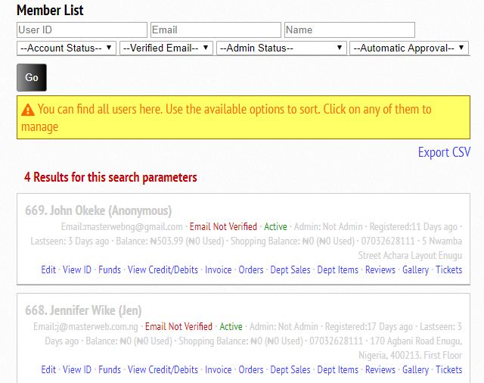
You can checkout all the options of what you can see about this user displayed in blue. Assuming this user is an admin, and is being used to collect sales funds for some specific items, you will be able to see the items in Department Items. Sales already remitted to it will also be accessed through Dept Sales. From Reviews, you will see all reviews written by this user. The gallery shows every file uploaded by this user.
User’s ID is the number displayed before the name of the user. The ID is separated from the name with a dot. See 668. And 669. above. The dots are not part of the ID.
We shall learn how to Edit a user account information, View user’s Identification details, Add/Deduct funds, and then view transactions on the user’s account.
To edit a user’s account information, click on Edit.
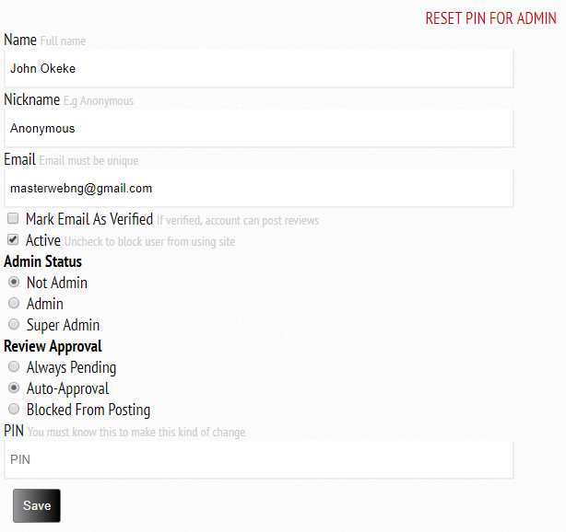
You can change the name, nickname, email, email verification status, account status, admin status and how review should be handled. You must type your PIN to be able to save this settings. A super admin has access to everything in the dashboard. An admin has access only to the non-sensitive parts. Please be careful about whom you make super-admin.
To Reset the PIN of a user, please click on the red link above.
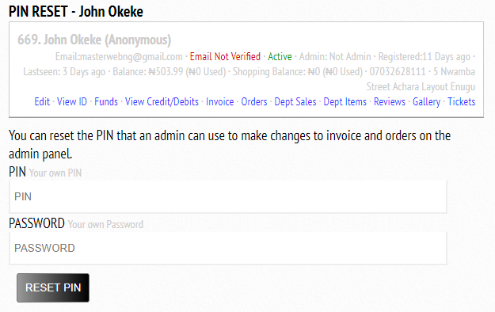

You must type your correct account password and PIN to reset the PIN for this account. When you reset the PIN, a new PIN will be displayed for you to copy and send to the user. Remember that only an admin needs a PIN. It would be pointless to set PIN for a non-admin.
To view the user’s identification details, simply click on the View ID
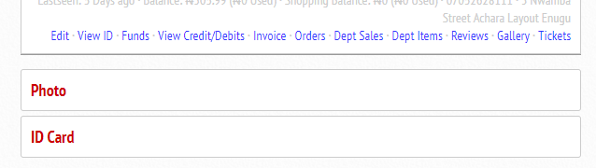
If this user has uploaded any photo or ID card, they will be displayed below. This can be useful in order processing, in case customer is purchasing items that are meant for people of certain age brackets. You can also use this to verify the identity of a person claiming ownership of an item being delivered. All receipt invoices carry a QR code that an admin can scan and be brought to a page where these information are available.

To add money or deduct money from a user’s account, click on Funds.
When adding money or deducting money from a user’s account, you need to specify if this is to be done on balance or shopping balance. Main balance can be withdrawn while shopping balance cannot be withdrawn but can be spent.
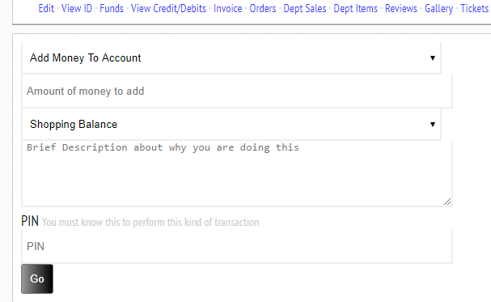
The first field can be used to select the action to be performed. The action can be Add money to Deduct Money. The next field is where you have to enter the amount of money to be added or deducted. The next field is where you select the source or destination of this transaction. This can be Shopping Balance or Main balance. Brief description is very important so that you can know why this transaction was performed. If this is a refund, please remember to type the invoice ID or the Order ID or the Withdrawal ID. If this is for a competition won, remember to state clear details. This will make auditing easier for you.
Now enter your PIN and click on Go and you should see the fund deducted or added to the account, depending on what action you performed.
To view all credit and debits that has happened on this user’s account, simply click on the View Credits and Debits.
You can also access this option for everyone from the More Power options so that you can view all credits and debits happening on the website.
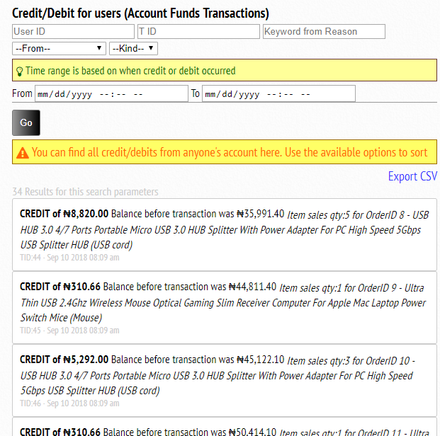

Managing Reviews
When review is activated and customers write reviews, it is important to check each review and mark as verified. This does can help make sure competitors and spammers are not taking advantage of your platform to sell their own goods. When you spot a review from a spammer, just go ahead and either edit the user’s discussion approval or block the person entirely if the account has not made any real purchases or shows no potential of making purchases.
To check new reviews that you have not yet checked to verify, scroll to the review section on the dashboard. You can see a link to view all reviews and another link to filter only the ones that you have not verified yet.
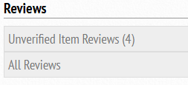
You will see reviews listed when you click on any of the options. There are also extra options to filter.
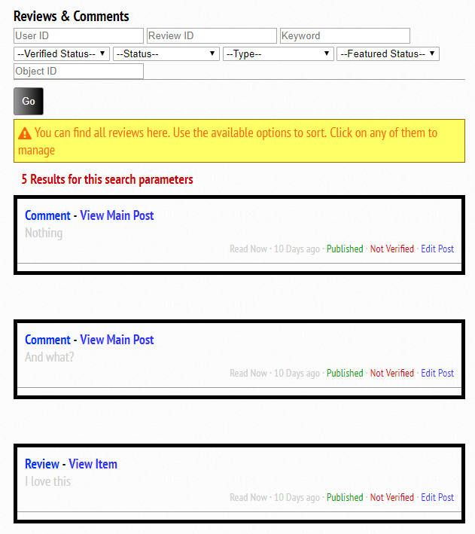
To edit any particular review, click on Edit Post. When you click on it, you can pick a lot of options such as whether to leave it published, mark it as featured (featured may be used on the homepage depending on how your homepage has been customized to function), mark as verified. Verified does not mean that this review is fit for publishing. It means that you have verified that it has been handled. The handling could be thrashed, pending or published. Marking it as verified means it will not be presented for you to attend to again, unless edited by the owner.
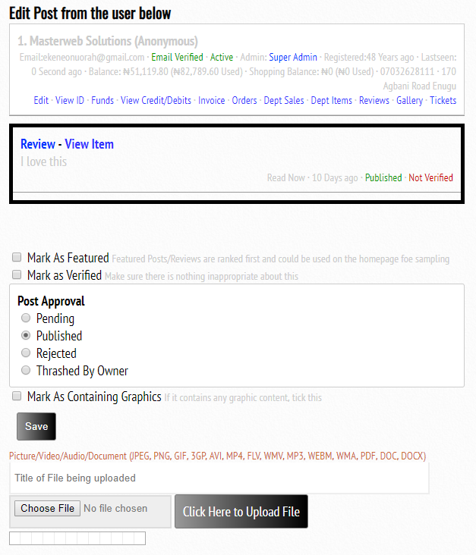
Click on save after you are done with editing the review.

Other Options
The parts that needed to be constantly attended to have all been treated. There are other important features that we may need to look at. CSV exporting, uploads and generating email lists are all part of this.

CSV Exporting
CSV exporting is available in users, invoices, orders, withdrawals and credit/debits that happen in user accounts. Several fields are present in the CSV exported. The file exported depends on the filter options that you have used. Open the exported file in excel sheet or any CSV document reader that you have, and use it to generate reports as needed.
The first row of these sheets are used to enter meta data such as time, possible column explanation and date/time when report was generated.
Below is an example of a sheet exported from the order.
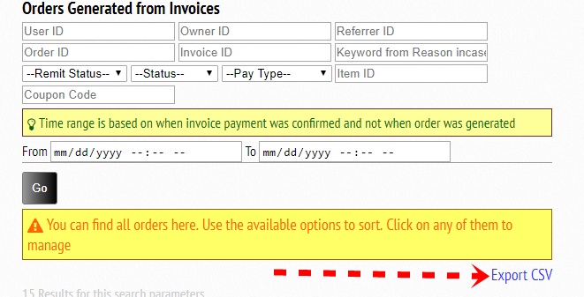
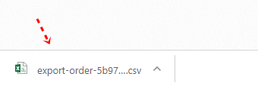

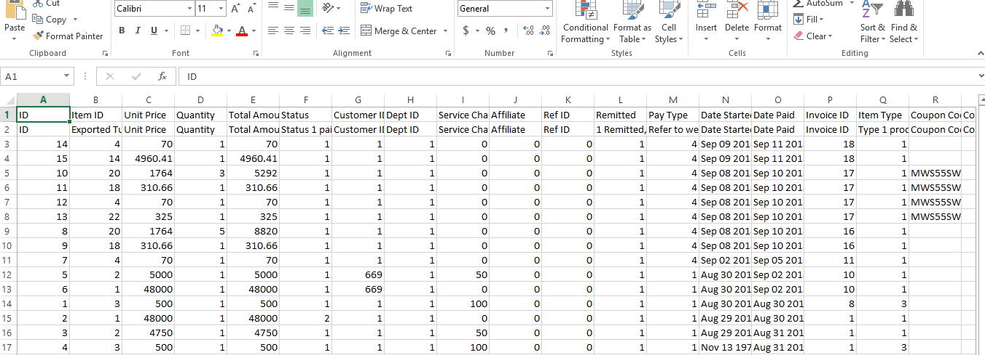

Uploads
To access all the files that have been uploaded in your website, you can scroll to the More Power options section in the dashboard and click on Browse Uploads.
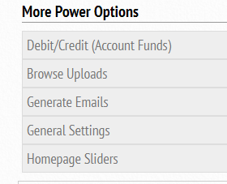
Locate the Browse Uploads link and click on it. You will see a list of all the files uploaded. You can delete any if you wish to. But this is not advisable, as you may not know what exactly might need this file.
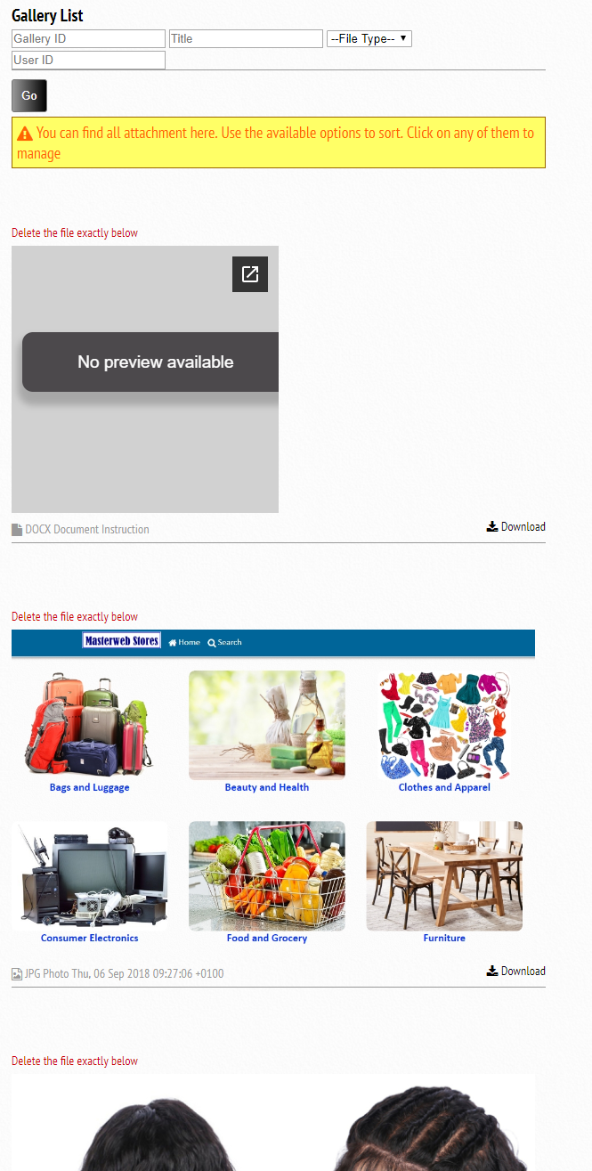

Generating Email List
Sending email to all your members should be possible if you can generate their emails in one place. You can use services like mailchimp to send mass emails. Locate the Generate emails from the More Power Options section in the dashboard.
When you click on it, you should see a page where you can use filter options to choose the email that you want.
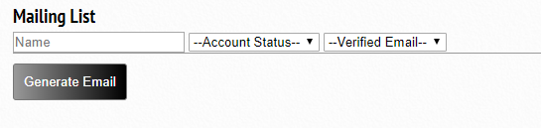
Click on generate email and you should see the emails generated for you. Mailchimp can accept email list in the format: Email <space> Customer Name <new line> Email <space> Customer Name.
If you need only emails, you can Google email extractor tool and past the text there. Names will be stripped off for you.

Developer Option
If you have code level access and you wish to edit the CSS to change some designs, please add your CSS to the file in _cdn/css/custom.css
This file is usually empty, and can be used to target elements, classes and IDs to change their css properties.
If not done here, you might cause issues with dark mode settings when activated.
There is a dark mode that visitors can activate. The link to activate it is at the bottom of the website. Once activated, the website looks somewhat like this:
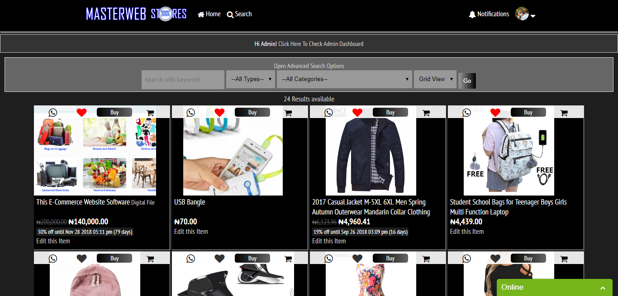

Additional Support
Please feel free to contact us for additional help if you have finished this document but still find it difficult to perform certain operations.
Our contact email is contact@masterweb.com.ng
Visit masterweb.com.ng for more

NOTES:
Please note that in setting up your store, we configure currency, payment options, colours, logo, accounts that receive certain funds such as delivery, VAT, and sales, all for free. We also guide the merchant in getting started. We offer one year free support.

